VARIANCE ESTIMATION WITH IMPUTED DATA

Pauli Ollila¹

¹ Statistics Finland, Finland
e-mail: Pauli.Ollila@stat.fi

Abstract

The paper describes briefly the theoretical framework of variance of an estimator in the presence of imputation and the basis for estimating the variance.

1 Introduction

The aim of this paper is to give a brief overview on variance and its estimation with imputed data. In the presentation in Ventspils there will be examples of different variance estimation methods applied with a real data set. Most of the terminology here is based on Berger et al. (2004), although the graphical presentation and some expressions are by the author of this paper. Berger et al. (2004) is a deliverable of the DACSEIS project (2001 − 2004) concentrating on different variance estimation issues in survey sampling. This deliverable (and other DACSEIS papers as well) are available on the DACSEIS site www.dacseis.de. Also the imputation bulletins of Statistics Canada provide important information on the topic, see e.g. Rao (2003) and Kalton (2003). Rao’s article also includes a somewhat comprehensive list of reference material.

2 Variance in the presence of non-response and imputation
2.1 Survey situation
The population U of size N includes realised variable values in matrix Y (k×N). One can make an assumption that there is an underlying superpopulation model ξ, which might have been behind the realised values of Y (Figure 1).
Figure 1. Population and parameter
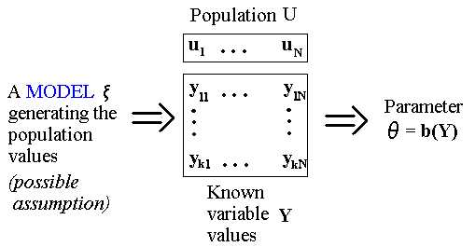
Theoretically sampling can be interpreted as a selection of a particular sample s_{c} size n_{s} with the probability p(s) [sampling design] from the set of all samples S. In practice we usually make the selection at the unit level following a scheme which fulfils the sampling design p(s). In this context this process is called as a sampling mechanism (Figure 2).
Figure 2. Sampling in theory and practice
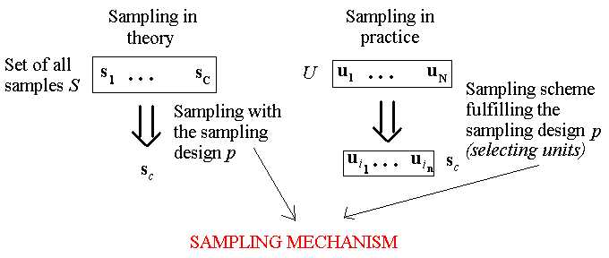
Almost always a survey includes unit non-response, and in many cases there is item non-response for certain variables as well. The matrix R^{(s)} with random variables R_{ji} (i∈s, j=1, …, k) describes for each observation which variable values are observed. There might be underlying reasons and patterns why persons do not respond or some people do not answer all the questions asked. The sample s can be divided into two groups considering variable y: respondents s_{r} of size r and non-respondents s_{m} of size m. Different non-response mechanisms can be assumed as possible causes for non-response (Figure 3). The probabilities p(R^{(s)}) generating R_{ji} are denoted by q. Alternatively one can express the situation in terms of a response mechanism. For example in the case of “Missing Completely At Random” (MCAR) values of the variable (or a set of variables) for a point estimator are missing completely at random if missingness is independent of all these variables. Furthermore, in “Missing At Random” (MAR) values are “missing at random given an additional set of measured variables if missingness is independent of the values of the variables which are missing, conditional on the observed values of both sets of variables” (Berger et al. 2004). The mechanisms can also be further developed, for more information see e.g. Little and Rubin (2002). A specific application of the non-response mechanism is to expand it to the population level (see e.g. Rubin 1987), i.e. R_{i} are defined for all i∈U. The resulting matrix is denoted R_{U}. In most of the approaches using the population non-response mechanism this matrix can be constructed under the assumption of independence of sampling and non-response, i.e. s and R_{U} are independent. Correspondingly q^{U} denote the probability distribution p(R_{U}).

Figure 3. Non-Response Mechanism
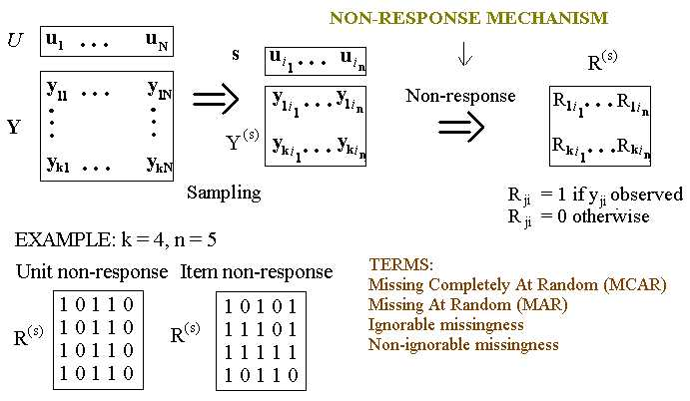
In most cases the unit non-response is dealt with weight adjustments. However, often in surveys there is a need to correct the item non-response by filling the missing information for variables according to a specific principle, i.e. under some imputation mechanism (Figure 4). The main reason behind imputation is the utilisation of the data for different analytic purposes, e.g. without imputation an analysis requiring several variables with item non-response concentrating on different observations in different variables may reduce the number of valid observations notably. The imputation based on marginal parameters (e.g. item totals, means, quantities [within groups]) is a simple way to solve the problem. A more sophisticated alternative is the modelling (e.g. regression or logistic regression based on auxiliary information, for the latter alternative see e.g. Ekholm and Laaksonen 1991) of the variable to be imputed. Auxiliary information is also utilised in the donor imputation, covering various techniques developed for the process (e.g. hot-deck imputation based on the order of another variable x in the data, which is in relation with the study variable y). Some imputation mechanisms are deterministic, i.e. the mechanisms do not produce any stochastic variation (e.g. simple mean imputation). On the other hand the mechanism can include variation (some donor methods) or it can be built in the mechanism (e.g. an error term in regression). Then the imputation mechanism is stochastic. In addition to these single imputation methods the multiple imputation methods (i.e. creating several imputed data sets for further operations) make a recent developing branch of imputation (Rubin 1987).

Figure 4. Imputation mechanism
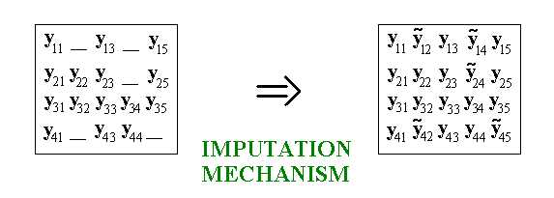
In order to get results the parameters of interest must be estimated. If there was no unit non-response, the weights w_{j} (j = 1, …, n) for sample observations to be used in estimation would be created according to the sampling design. In the case of unit non-response weight adjustments would be carried out. For the variables with item non-response the use of these weights may provide biased estimates; most clearly this can be seen when estimating the total of a variable. In the case of imputation these weights can be used (Figure 5). However, if the variation is not introduced in the imputation mechanism (deterministic imputation), we end up usually too low standard errors when calculated from the imputed data.
Figure 5. Estimation
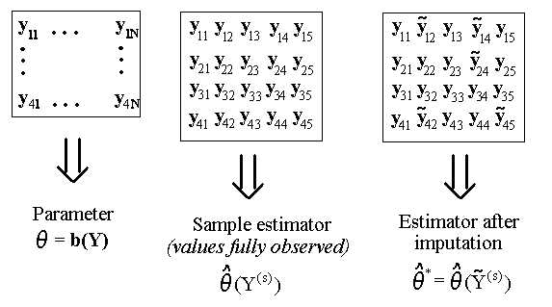
2.2 Sources of variation
What is the variance of the estimator including imputation, i.e. $V({\hat{θ}}^{})$? In the beginning one should determine what are the sources of variation in the whole process including the construction of the population, sampling, occurrence of non-response and conducting imputation (Figure 6). In the design-based approach the effect of the sampling mechanism cannot be avoided. Furthermore, there should always be an assumption of the non-response mechanism behind s_{m} in order to study the properties of the imputed estimator. The simplest assumption is that every observation has the same non-response probability for variable y. If there is a stochastic element in the imputation mechanism, that aspect is taken into account. An interesting alternative (see e.g. Deville and Särndal 1994) is to introduce dependence upon a model ξ (which is assumed to generate the population values) for the y_{i} into the variance. This model-anticipated variance E_{ξ}V_{pq} (or E_{ξ}V_{pqI}) applies the model-assisted regression theory familiar from Särndal, Swensson and Wretman (1992) as the case when non-response is treated as the second phase of selection incurred after the sample selection. The subscripts in the variances expressed in Figure 6 show the impact of different sources of variation.
Figure 6. Sources of variation
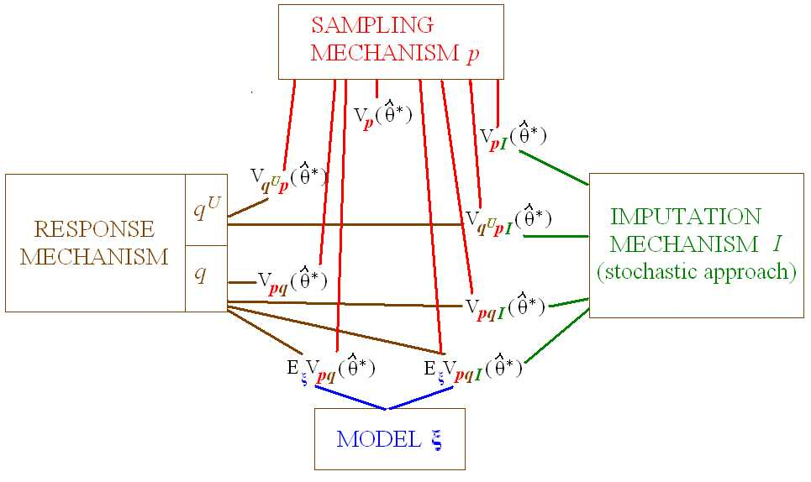
The principle of constructing the variance $V({\hat{θ}}^{})$ is theoretically rather simple. The sources of variation are decomposed into separate terms. For example, including the variation of the sampling mechanism and the response mechanisms provides the decomposition $V_{\text{pq}}({\hat{θ}}^{})=V_{p}E_{q}({\hat{θ}}^{})+E_{p}V_{q}({\hat{θ}}^{})$. When a third variation term is introduced, a further decomposition is conducted. These decomposition parts form the basis for variance estimation considering different sources of variation.
2.3 Variance Estimation
After defining the variance to be estimated, one should decide the method to be used in variance estimation (Figure 7). The complexity of the estimator is an important issue. Then one decision (partially connected to the sources of variation) is the same as in the case of non-imputed data: should we choose the analytic approach strictly based on the existing imputed data, possibly with an inflation factor (only for simple estimators); should we make a linearisation or other approximation of the estimator for variance estimation or should we concentrate on resampling methods (jackknife, bootstrap). A recent alternative is also the linearisation of the jackknife variance estimator (in the presence of imputation e.g. Sitter and Rao 1997, Berger et al. 2004). The analytic and linearisation methods usually apply the plug-in data, which can be imputed data, but it may also include values adjusted for variance estimation purposes or it does not need to include all item non-response imputed (e.g. for variance estimation of regression imputation). The resampling methods may include the non-response mechanism and imputation mechanism more or less. An example of a construction of the population non-response mechanism is a modification of Sitter’s bootstrap without replacement procedure (1992) with a pseudopopulation including a non-response structure (Berger et al. 2004).
Figure 7. Variance estimation
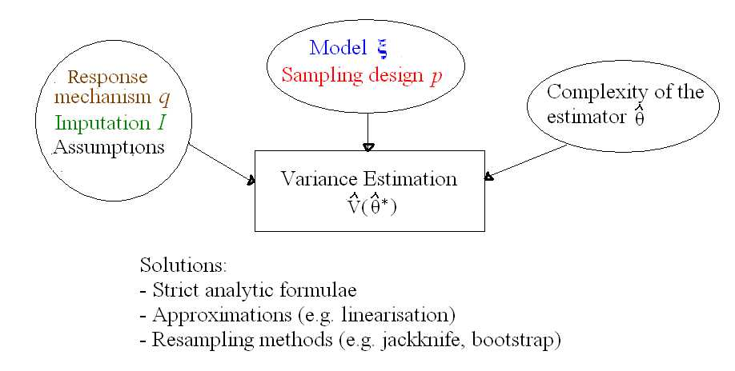
Another decision is how to estimate the different sources of variation defined in the variance and to take the effect of the underlying assumptions into account. Then a crucial question is that from where we get the information for estimation of the different parts of variance. In suitable situations (e.g. small sampling fractions) some parts can be interpreted as negligible. Some expressions can be simplified with assumptions, e.g. estimating $V_{p}E_{I}({\hat{θ}}^{})$ simply with ${\hat{V}}_{p}({\hat{θ}}^{})$, which can be calculated in the absence of missing data with a non-response adjustment. Evidently one cannot always make such assumptions.

For the terms including the population response mechanism q^{U} one may develop e.g. linearisation functions of existing data values according to the structure of the mechanism and independence assumptions behind that (see Shao and Steel 1999). The usual way of introducing the non-response mechanism at the sample level (i.e. q) in the terms of variance estimation is the framework of two-phase sampling (e.g. Rao 2003), where we have the path population U --> complete sample s --> sample of respondents s_{r} . Methods for variance estimation in this case are developed utilising linearisation, resampling methods and linearised jackknife. See Rao (2003) and Berger et al. (2004) for more information.

If the imputation is stochastic, the variance estimator ${\hat{V}}_{I}({\hat{θ}}^{})$ should be somehow constructed, and this might be conducted e.g. by replication methods taking the stochastic nature of imputation into account or by theoretical adjustments in the case of regression with an additional error term. The terms including the model ξ can be constructed based on the structure of the model and the assumptions and auxiliary information behind it (Deville and Särndal 1994).

Examples of variance estimation methods with a real data set are shown (with some paper copies of presentation) in the workshop in Ventspils.
References
Berger, Y., Björnstad, J., Zhang, L-C., Skinner, C. (2004) Imputation and Non-response. DACSEIS Deliverable 11.1.
Deville, J. and Särndal, C-E. (1994) Variance Estimation for the Regression Imputed Horvitz-Thompson Estimator. Journal of Official Statistics 10, 381-394.
Ekholm, A. and Laaksonen, S. (1991) Weighting via Response Modelling in the Finnish Household Budget Survey. Journal of Official Statistics 7, 325-337.
Kalton, G. (2003) Imputation methods. The Imputation Bulletin
Little, R. and Rubin, D. (2002) Statistical Analysis with Missing Data, Second edition. New York: John Wiley & Sons.
Rao, J. N. K. (2003) Variance Estimation in the Presence of Imputation for Item Non-response. The Imputation Bulletin, 3, 2-6, Statistics Canada.
Shao, J. and Steel, P. (1999) Variance Estimation with Composite Imputation and Non-negligible Sampling Fractions, Journal of the American Statistical Association 94, 254-265.
Sitter, R. R. (1992) Comparing Three Bootstrap Methods for Survey Data. Canadian Journal of Statistics 20, 135-154.
Sitter, R. R. and Rao, J. N. K. (1997) Imputation for Missing Values and Corresponding Variance Estimation. Canadian Journal of Statistics 25, 61-75.
Rubin, D. (1987) Multiple Imputation for Non-response in Surveys. New York: Wiley.
Särndal, C-E., Swensson, B. and Wretman, J. (1992) Model Assisted Survey Sampling. New York: Springer-Verlag.

